
A 10
Set No : 1
Sreenidhi Institute of Science & Technology
(An Autonomous Institution)
Code No: 101MA01/111MA01

B. TECH. I – Year I – Semester Examinations, January, 2012 (Regular)
ENGINEERING MATHEMATICS – I ( Common to EEE, ECE, ECM )

Time: 3 Hours Max. Marks : 70

Note : No additional answer sheets will be provided.

Part-A (Objective Type)
Max.Marks:20

Answer all QUESTIONS.

1. Prove that the matrix 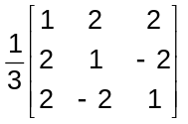 is orthogonal.
2. Find the eigen values of the matrix 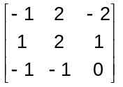
3. Evaluate 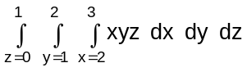.

4. Determine the nature of the series 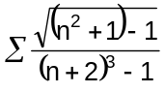
5. Verify Cauchy's mean value theorem for the functions e^{x} and e^{-x} in the interval (a,b).

6. Find the radius of curvature at (at²,2at) of the parabola y²=4ax.

7. Find the maximum and minimum values of 3x⁴-2x³-6x²+6x+1 in the interval (0,2).

8. Find the asymptote of the curve y²(a-x)=x²(a+x) parallel to y axis.

9. The curve y²(2a-x)=x³ is symmetrical about which axis.

10. Envelope of family of lines y=mx-a/m where m is a parameter and a is constant.

Part – B
Max. Marks: 50

ANSWER ANY FIVE QUESTIONS. EACH QUESTION CARRIES 10 MARKS.

1. a) If A = 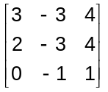, show that A³=A⁻¹.
b) Investigate the consistency of the following equations and if possible find the solutions.
4x-2y+6z=8; x+y-3z=-1; 15x-3y+9z=21

2. a) Find the characteristic equation of the matrix A = 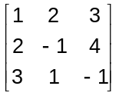 and hence verify Cayley - Hamilton theorem.
b) Using Cayley-Hamilton theorem find the inverse of 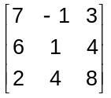.

3. Reduce the quadratic form 3x²+5y²+3z²-2yz+2xz-2xy to canonical form.

4. a) Test the convergence of the series
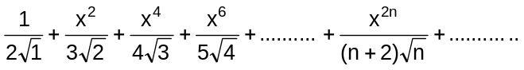.

b) If f(x)=sin⁻¹(x), 0<a<b<1, use mean value theorem to prove that 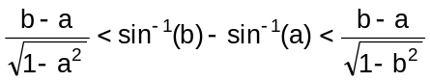.

5. a) If u = x²-y², v = 2xy and x = rcosθ, y = rsinθ then find 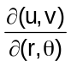.
b) A rectangular box open at the top is to have volume of 32 cubic ft. Find the dimensions of the box requiring least material for its construction.

6. a) Show that the functions u=x+y+z, v=xy+yz+zx and w=x²+y²+z² are functionally dependent and find the relation between them if they are functionally dependent.

b) Find the radius of curvature ρ at any point of the cycloid x=a(θ+sinθ), y=a(1-cosθ). Hence find ρ at 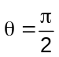.

7. a) Show that the radius of curvature at any point of the asteroid 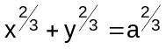, is three times the length of the perpendicular from the origin to the tangent at that point.

b) Show that the evolute of the cycloid x = a(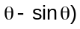; y = a(1-cos) is another equal cycloid.

8. a) Evaluate 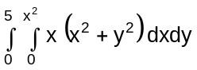
b) Evaluate 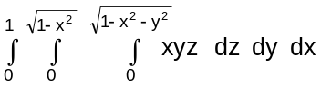

-- 00 -- 00 --

